First, go to https://www.gradescope.com/
Use username ajyzhang@ucdavis.edu and pw Lzydavid19980723 to log in.
Then select ECS 34
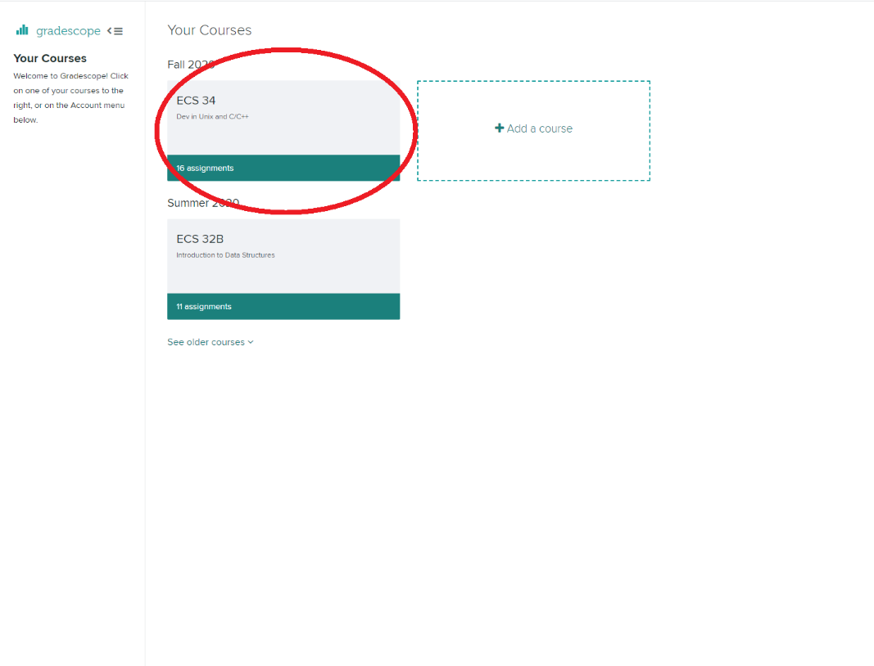
Then select Programming HW 6
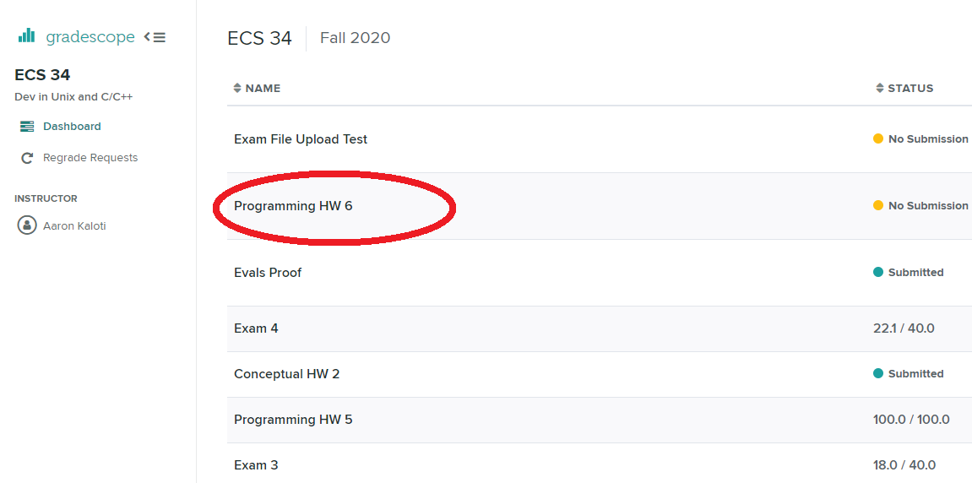
Then click resubmit button on the bottom side.
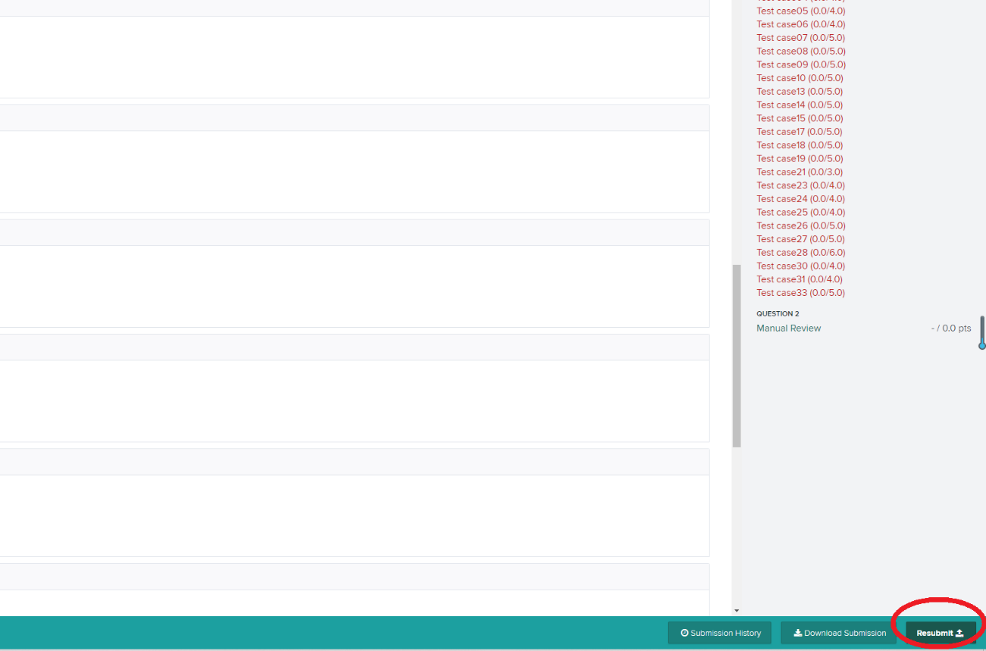
There is no submission limits, you can submit as many times as you want.

